**#Python Session 1 - Assignment 1 - Task 1 – Q1**

Was unable to open the link given in assignment1.pdf to open the first program

**#Python Session 1 - Assignment 1 - Task 1 - Q2**

for i in range(2000,3201):

if (i%7==0 and i/5!=0):

print(i,end=",")

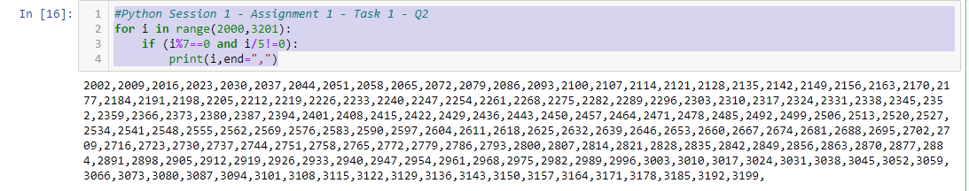

**#Python Session 1 - Assignment 1 - Task 1 - Q3**

a=input("First name: ")

b=input("Last name: ")

print(b,a)

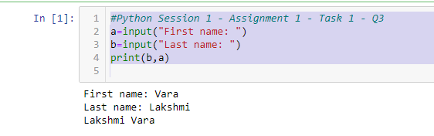

**#Python Session 1 - Assignment 1 - Task 1 - Q4**

d=12

r=d/2

v=(4/3)*3.14*(r**3)

print("Volume of Sphere:",v)

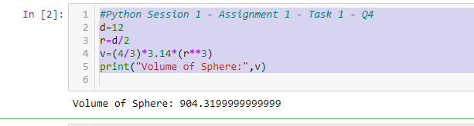

**#Python Session 1 - Assignment 1 - Task 2 - Q1**

x=input("Enter numbers")

list1=x.split(",")

for i in range(0,len(list1)):

list1[i]=int(list1[i])

print(list1)

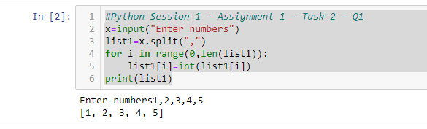

**#Python Session 1 - Assignment 1 - Task 2 - Q2**

for j in range(6):

print("*"*j)

if j==5:

for i in range(4,0,-1):

print("*"*i)

break

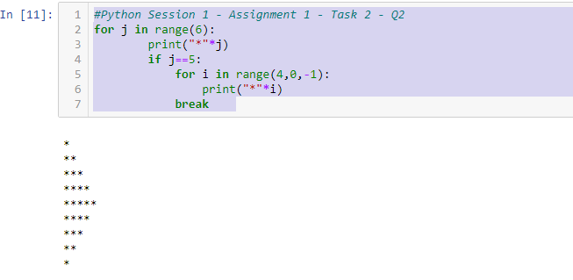

**#Python Session 1 - Assignment 1 - Task 2 - Q3**

x=input("Enter a word: ")

list1=list(reversed(x))

print("".join(list1))

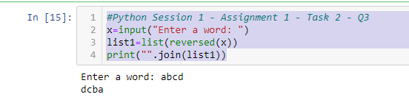

**#Python Session 1 - Assignment 1 - Task 2 - Q4**

string1="WE, THE PEOPLE OF INDIA, having solemnly resolved to constitute India into a SOVEREIGN, SOCIALIST, SECULAR, DEMOCRATIC REPUBLIC and to secure to all its citizens"

list1=list(string1.split())

for i in list1:

if i=='INDIA,':

print(i,end="\n\t")

elif i=='SOVEREIGN,':

print(i+" !",end="\n\t\t")

elif i=="REPUBLIC":

print(i,end="\n\t\t ")

else:

print(i,end=" ")

